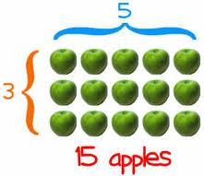
Lesson: Multiplying 2 Digits x 2 Digits
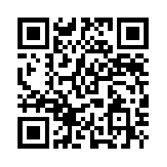
Use the Ipad or Netbook with video cam in your group and use the QR reader to open the video. Listen to the lesson then follow the instructions below.
Directions: Answer the following problems, showing all work. If you need a hint or extra help, you can use a device in your center to read the QR Code or ask a teacher for help.
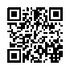
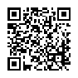
Hints:

Show your work here: (Number your work)
- 47 x 76
Answer:______

- 38 X 90
Answer:______

- 56 X 41
Answer:______

- 93 X 26
Answer:______

- 87 X 33
Answer:______

